Assignment 26.4

Problem Statement

Implement view in hive by following the steps in the below blog <https://acadgild.com/blog/hive-view-introduction/>

Emp_data table

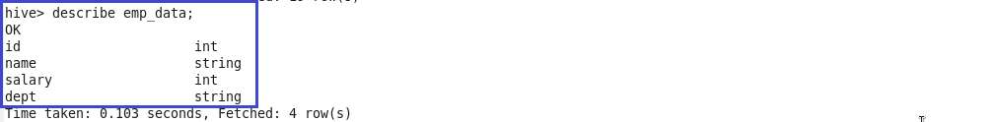

A view named emp_view is created for emp_data table with columns name ,salary,lag salary as shown.

